

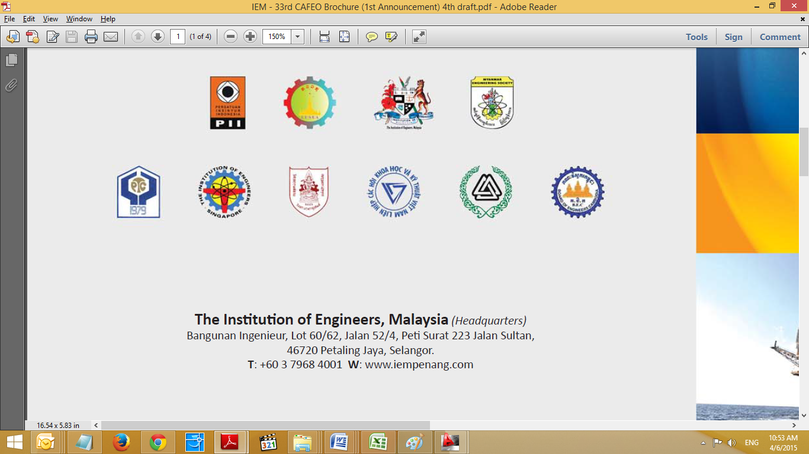
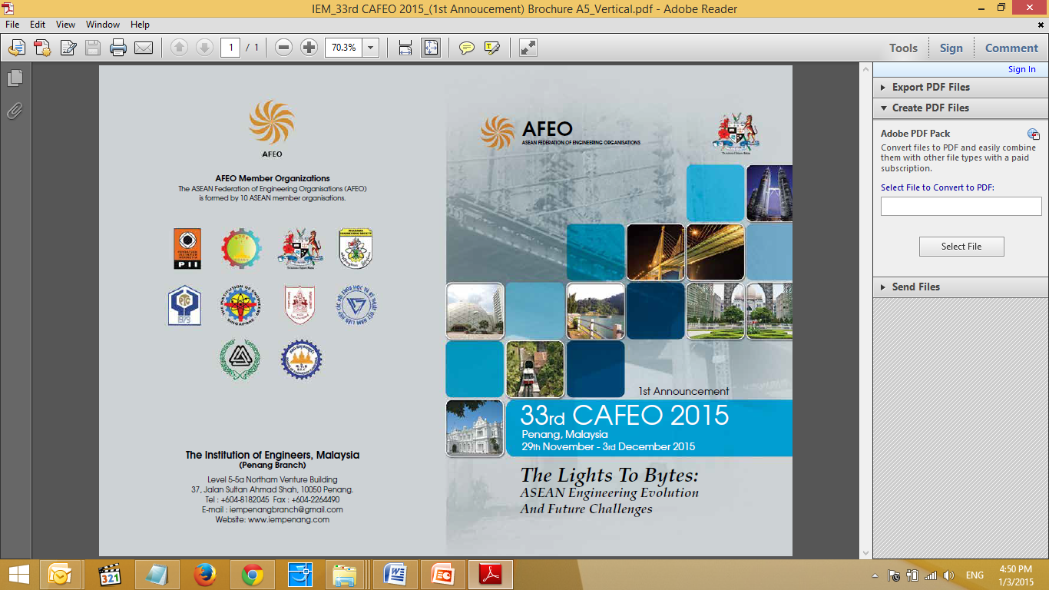
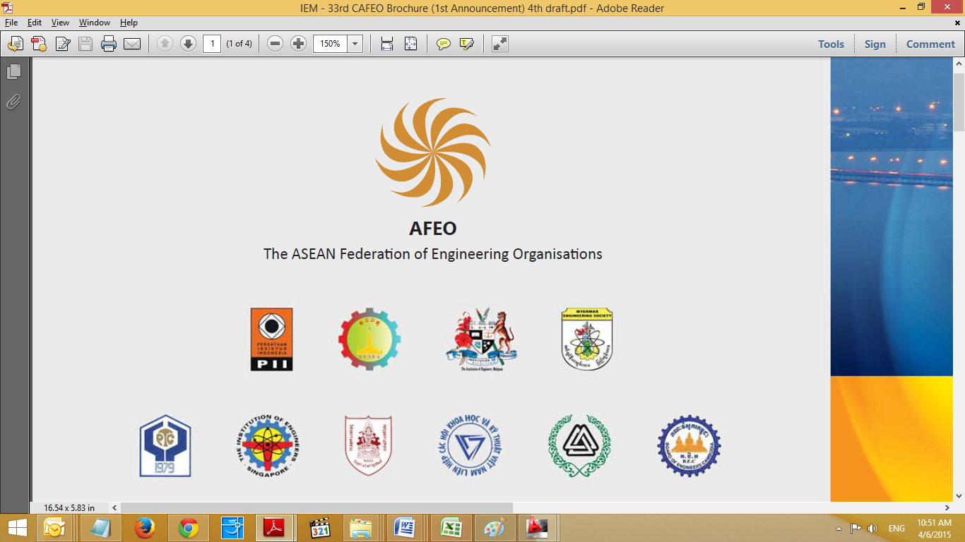
BACKGROUND
CAFEO 33, 2015
Penang, Malaysia
From Light to Bytes:
ASEAN Engineering Evolution And Future Challenges

REGISTRATION FORM
The ASEAN Federation of Engineering Organizations (AFEO) is a non-governmental organization affiliated to the ASEAN Secretariat. Members of the AFEO are Engineering Institutions and Unions of countries in ASEAN. The objectives of AFEO are the promotion of goodwill, understanding, cooperation and exchange of ideas and experiences in the fields of education, science, engineering, technology, environment, human resource, training and registration of professional engineers.
The Conference of the ASEAN Federation of Engineering Organizations (CAFEO) has been held annually since 1982 by 10 ASEAN member countries, namely, Brunei, Indonesia, Malaysia, Singapore, Philippines, Thailand, Cambodia, Vietnam, Laos and Myanmar. The CAFEO has also attracted the participation of engineering organizations of the USA, Japan, Korea, Australia, China, India, Germany and the UK, the World Federation of Engineering Organizations (WFEO) and ASEAN Academy of Engineering and Technology (AAET).

The Institution of Engineers, Malaysia is hosting the 33rd Conference of the ASEAN Federation of Engineering Organization 2015 to be held from 22nd to 26th November. Penang is the hosting city for CAFEO 33, 2015.
The Institution of Engineers, Malaysia (IEM) Penang Branch, as the main host, is pleased to invite other engineering organizations, universities and R&D institutions to participate in this prestigious conference & exhibition with the theme below:
THEMES
From Light to Bytes: ASEAN Engineering Evolution and Future Challenges
In 1786, Captain Francis Light discovered George Town; a strategic occupation that acknowledged Penang’s natural resources, harbour and its potential for commerce and as a British command station. From a humble trading port, Penang has developed over two centuries into a vital, world-class hub for commerce, manufacturing, modernization, cultures and tourism that it is today. It has been dubbed the Silicon Valley of Southeast Asia, most livable and best city and a World Heritage Site. The iconic Penang Bridge was Southeast Asia’s longest in 1985 and Komtar Tower was Asia’s tallest building in 1986. Today exists an even longer Second Penang Bridge. Like other ASEAN big cities, Penang’s tremendous growth was in big part thanks to the huge number of engineers working diligently behind the scene. As key builders, engineers would continue to face up to the challenges of designing and constructing many future ASEAN “world cities.”
SUB-THEMES
- Integrated public transportation system in urban development.
- Electrical, electronic, mechanical, information and communication technology engineering.
- Engineering and technology for sustainable infrastructure design.
- Chemical and environmental engineering development.
- Engineering education and women engineering in developing countries.
CONFERENCE REGISTRATION FEES
The registration fee for conference delegates would include session, tea breaks, lunches and welcoming reception and farewell banquet dinner. The registration fee for AFEO delegates are as follows:

AFEO Delegate USD 100 or RM380
Accompanying Person USD 100 or RM380
YEAFEO Delegate USD 60 or RM228
Non AFEO USD 200 or RM760
REGISTRATION
In order to facilitate the planning of the Conference, those wishing to attend are requested to register online at cafeo33.iempenang.org or to complete and return the Registration Form given at the back of this brochure, and return to the CAFEO Secretariat by email, mail or fax (Refer to the contact detail on following section) as early as possible to facilitate our preparation of your participation.

The first 100 delegates who successfully registered with full payment through online or CAFEO secretariat will be given a door gift.

ENTITLEMENT OF REGISTERED PARTICIPANT

- Entitled to 1 set of papers and Conference bag
- Entrance to all technical sessions, lunches and teas
- Attendance to all official functions during the Conference
- Attend Opening Ceremony and Closing Ceremony
- Participate in Technical Visits

SPOUSE/ACCOMPANYING PERSON PROGRAMME

The Organizing Committee has arranged programmes for accompanying spouse/person to historical monuments, tourism and commercial centres in Penang. The registration fee shall be USD 30 or RM114 for the 2 tours below:

24th November 2015 (14.30 pm to 18.30 pm) - Island Tour
- Balik Pulau – Nutmeg Factory
- Teluk Bahang Dam
- Botanical Garden
- Reclining Buddha

25th November 2015 (9.00 am to 13.00 pm) - Heritage Tour
- Fort Cornwallis
- Peranakan Mansion
- Guan Yin Temple
- Art Street
- Clan Jetty

CORRESPONDENCE ADDRESS FOR CONFERENCE SECRETARIAT

The Institution of Engineers, Malaysia (Penang Branch)
Level 5-5a Northam Venture Building,
37, Jalan Sultan Ahmad Shah,
10050 Georgetown, Penang, Malaysia.
Tel No.: +60 4 818 2045
Fax No. : +60 4 226 4490
Email: cafeo33@iempenang.org

CONFERENCE VENUE
Hotel Equatorial (Penang) will be the main conference hotel. Please refer to the followings details:

Hotel Equatorial Penang
Jalan Bukit Jambul, 11900 Penang
T: +60 4 632 7000 F: +60 4 632 7100
E: info@pen.equatorial.com
W: www.hotel-equatorial-penang.com

RECOMMENDED HOTELS

Eastin Hotel Penang  1 Solok Bayan Indah, Queensbay,  11900 Bayan Lepas, Penang  T: +60 4 612 1111  W: http://web.eastinhotel-penang.com | Jen Hotel Penang  Magazine Road, George Town, Penang, 10300, Malaysia  T: +60 4 262 2622  W: www.hoteljen.com
Vistana Hotel Penang  213, Jalan Bukit Gambir, Bukit Jambul,  11950 Penang  T: +60 4 646 8000  W: http://www.vistanahotels.com | Alora Hotel Penang  B Tower, Bayan Point, 19,  Medan Kampung Relau, 11900 Penang. Malaysia.  T: +60 4 646 7777  W: www.alorahotel.com

CONFERENCE SCHEDULE – CAFEO 33, 2015
22.11.15  Sunday | 23.11.15  Monday |  |  | 24.11.15  Tuesday |  |  |  | 25.11.15  Wednesday |  |  |  | 26.11.15  Thursday
Arrival for Golfers at  Penang  Registration  Non-Golfers, if any  Free and Easy)  0900 – 2000 | Golf Competition  0630 – 1230 |  |  | Arrival of delegates, Registration of Conference Delegates and Participants  Arrival of VIP Guests  Arrival of Guests of Honour  0800 – 0900 |  |  |  | FEIAP Meeting  0900 - 1100 | YEAFEO Young Engineers Country Report  0900 – 1100 | WE-AFEO  (Woman Section)  Country Report  0900 - 1100 | Technical Seminar  CAFEO 33 conference  0900 - 1100 | Technical Visits  Option 1  i) Mengkuang Dam  ii) SanDisk Storage Factory  Option 2  i) Batu Kawan Industrial Park and Bayan Lepas Free Trade Zone  ii) Boon Siew Honda Factory  Option 3  i) Water Front Development  ii) Steel Fabrication Plant  0900 - 1800
YEAFEO Heritage Hunt
1000 – 1400
 | Arrival of Officials, Foreign Delegations, Presidents and etc AFEO/YEAFEO/AER/WEAFEO  Registration of Conference Delegates and Participants  0900 – 1800 |  |  | Official Opening of CAFEO 33  Speeches, conferment of Hon. Patron and Visit Exhibition Hall  0900 – 10.30  VIP viewing the exhibition booth until  11.30
 | Free and Easy  (OWN LUNCH)  0730 – 1300 |  |  | Tea Break  1000 - 1030 |  |  |  | Tea Break  1100 - 1130
 | Working Group A  (Education and Capacity Building)  1300 - 1500 | Working Group B  (Transportation and Logistic)  1300 – 1500 | Working Group F  (Energy)  1300 – 1500 | AER Meeting  1030 - 1300 | YEAFEO Workshop session  1030 – 1300 | WE-AFEO  Board Meeting  (Woman Section)  1030-1300 | Technical Seminar  CAFEO 33 conference  10.30-1300 | AFEO Governing Board  1130 – 1230 | YEAFEO  Young Engineers Activities  1130 – 1230 | WE-AFEO  (Woman Section)  Country Report  1130 – 1230 | Technical Seminar  CAFEO 33 conference  1130 – 1230
 |  |  |  | Lunch  1300 – 1400 |  |  |  | Lunch  1230 – 1330
 | Working Group C  (Environmental Engineering)  1400 - 1500 | Working Group D  (Disaster Preparedness, Mitigation and Management)  1400 – 1500 | Working Group E  (Smart Sustainable City)  1400 – 1500
 |  |  |  | Country Report  1400 – 1530 |  |  |  | Technical Seminar  CAFEO 33 conference  1330 – 1530 | YEAFEO  Young Engineers Activities  1330 – 1530 | WE-AFEO Forum (Woman Section)  1330 – 1530 | Technical Seminar  CAFEO 33 conference  1330 – 1530
 | Tea Break  1500 – 1530 |  |  | Tea Break  1530 – 1600 |  |  |  | Tea Break  1530 – 1600
 | Award Meeting  1530 – 1630 |  |  | Country Report (continue)  1600 – 1700 |  |  |  | Free and Easy  1600 – 1800
 | Working Group G  (Ad Hoc Committee on Mobility of Engineers Forum)  1630 – 1730 |  |  | YEAFEO Board Meeting  (Young Engineers)  1630 - 1800 |  | WEAFEO Meeting  (Woman Section)  1630 – 1800 |  | Closing Ceremony  Closing Banquet & IEM Penang Branch 48th Anniversary Dinner  Presentation of ASEAN Engineering Achievement Award  Conferment of Distinguished Hon Fellow  Conferment of Hon Fellow  Conferment of Hon Member  Performance of delegates from ASEAN Countries and other foreign delegates  Flag Hand over to the incoming President of CAFEO 34  1800 – 2200
Free and Easy
1730 – 1830
Welcoming Reception
AER/AAE/AET/AAET/AT/AAT Certificate Presentation
1830 – 2100

 | End Event  Free and Easy |  |  | End Event  Free and Easy |  |  |  | End Event  Free and Easy |  |  |  | End Event  Free and Easy
The CAFEO 33 Final Programme is to be announced via cafeo33.iempenang.org or https://www.facebook.com/cafeo33
CONFERENCE SCHEDULE – YEAFEO 2015

22.11.15 | 23.11.15 | 24.11.15 | 25.11.15 | 26.11.15
Sunday | Monday | Tuesday | Wednesday | Thursday
Arrival of YEAFEO Delegates | YEAFEO Heritage Hunt  7.30am - 2.00pm | Arrival of delegates  8.00 am-9.00 am | YEAFEO Country Report Presentation  9.00 am-11.00 am | Optional - Join CAFEO Technical Visit  Option 1  i) Mengkuang Dam  ii) SanDisk Storage Factory  Option 2  i) Batu Kawan Industrial Park and Bayan  Lepas Free Trade Zone  ii) Boon Siew Honda Factory  Option 3  i) Water Front Development  ii) Steel Fabrication Plant  0900 - 1800
Arrival of YEAFEO Delegates | YEAFEO Heritage Hunt  7.30am - 2.00pm | Attend CAFEO Opening Ceremony  9.00 am-10.00 am | YEAFEO Country Report Presentation  9.00 am-11.00 am
Arrival of YEAFEO Delegates | YEAFEO Heritage Hunt  7.30am - 2.00pm | Tea Break  10.00 am-10.30 am | YEAFEO Country Report Presentation  9.00 am-11.00 am
Arrival of YEAFEO Delegates | YEAFEO Heritage Hunt  7.30am - 2.00pm | YEAFEO Working Group(s) Meeting  10.30 am-1.00 pm | YEAFEO Country Report Presentation  9.00 am-11.00 am
Arrival of YEAFEO Delegates | YEAFEO Heritage Hunt  7.30am - 2.00pm | YEAFEO Working Group(s) Meeting  10.30 am-1.00 pm | Tea Break  11.00 am-11.30 am
Arrival of YEAFEO Delegates | YEAFEO Heritage Hunt  7.30am - 2.00pm | YEAFEO Working Group(s) Meeting  10.30 am-1.00 pm | Inspire me Talk  11.30 am-12.30 pm
Arrival of YEAFEO Delegates | YEAFEO Heritage Hunt  7.30am - 2.00pm | YEAFEO Working Group(s) Meeting  10.30 am-1.00 pm | Lunch  12.30 pm-1.30 pm
Arrival of YEAFEO Delegates | YEAFEO Heritage Hunt  7.30am - 2.00pm | Lunch  1.00 pm-2.00 pm | Lunch  12.30 pm-1.30 pm
Arrival of YEAFEO Delegates | YEAFEO Heritage Hunt  7.30am - 2.00pm | Lunch  1.00 pm-2.00 pm | YEAFEO Technical Visit  (SPICE Project Site)  1.30 pm-4.00 pm
Arrival of YEAFEO Delegates | YEAFEO Registration  2.00pm - 6.30pm | Attend AFEO Country Report Presentation  2.00 pm-3.30 pm
Arrival of YEAFEO Delegates | YEAFEO Registration  2.00pm - 6.30pm | Tea Break  3.30 pm-4.00 pm
Arrival of YEAFEO Delegates | YEAFEO Registration  2.00pm - 6.30pm | Continue AFEO Country Report Presentation  4.00 pm-4.30 pm | Free & Easy  4.00 pm-6.30 pm
Arrival of YEAFEO Delegates | YEAFEO Registration  2.00pm - 6.30pm | YEAFEO Governing Board Meeting  4.30 pm-6.30 pm | Free & Easy  4.00 pm-6.30 pm
Arrival of YEAFEO Delegates | Welcoming Reception at Penang Equatorial Hotel  6.30pm - 9.30 pm | Optional Tour -  Penang 2nd Bridge + Penang Ferry Tour (Dinner Included)  6.30 pm-9.30 pm | Free & Easy  4.00 pm-6.30 pm
Arrival of YEAFEO Delegates |  |  | Closing Ceremony + Dinner  7.00 pm-11.30 pm
Arrival of YEAFEO Delegates |  | Optional - Networking Session  9.30 pm-12.00 am | Closing Ceremony + Dinner  7.00 pm-11.30 pm
Arrival of YEAFEO Delegates | Free & Easy | Optional - Networking Session  9.30 pm-12.00 am | Closing Ceremony + Dinner  7.00 pm-11.30 pm
Arrival of YEAFEO Delegates | Free & Easy | Optional - Networking Session  9.30 pm-12.00 am | Free & Easy

The YEAFEO Final Programme is to be announced via cafeo33.iempenang.org or https://www.facebook.com/cafeo33

REGISTRATION FORM (CAFEO 33, 2015)
CAFEO 33, 2015 Conference Secretariat
The Institution of Engineers, Malaysia (Penang Branch)
Level 5-5a Northam Venture Building,
37, Jalan Sultan Ahmad Shah, 10050 Georgetown, Penang, Malaysia.
Tel No.: +60 4 818 2045
Fax No. : +60 4 226 4490
Email: cafeo33@iempenang.org
Name: | ______________________________ 􀆟Mr.􀆟Mrs.􀆟Ir. 􀆟AER. 􀆟Others:
Gender: | 􀆟Male 􀆟Female
Date of Birth: | _____/_____/______ dd/MM/yy
Attending as: | 􀆟AFEO Delegate USD 100 or RM380
AFEO Organisation: | PII
Nationality: | Indonesia
Identification Documents: | ________________________________􀆟NRIC 􀆟Passport
Tel No (Office) : | ____________________
Tel No (Handphone) : | ____________________
Email : | ________________________________
Address: | _______________________________________________
 | _______________________________________________
Emergency Contact
Name: | _______________________________________________
Contact Number: | ________________ Relationship: ___________________

________________ __________________
Date Signature
(Photostat copies are acceptable)

Online Registration is available at cafeo33.iempenang.org.
Delegates are encouraged to register online for better and more convenient experience.

REGISTRATION FORM (CAFEO 33, 2015)
Flight Details
(Kindly provide flight details so we will arrange for transport to pick you at the airport.)
Arrival Date: | _____/_____/______ dd/MM/yy
Arrival Time: | _________________ HH/mm
Arrival Flight Number: | _________________
Departure Date: | _____/_____/______ dd/MM/yy
Departure Time: | _________________ HH/mm
Departure Flight Number: | _________________
Technical Visits
Please choose the appropriate option:
Option 1 􀆟 Mengkuang Dam & SanDisk Storage Factory (By Coach)
Option 2 􀆟 Batu Kawan Industrial Park and Bayan Lepas Free Trade Zone & Boon Siew Honda Factory
(By Coach)
Option 3 􀆟 Water Front Development & Steel Fabrication Plant (By Coach)
􀆟 Not Attending Technical Visits

Accommodation
Please choose the appropriate option:
􀆟 Hotel Equatorial Penang 􀆟 Vistana Hotel Penang 􀆟 Eastin Hotel Penang Alora Hotel Penang
􀆟 Jen Hotel Penang 􀆟 Others _________________

Spouse Programme
I will be accompanied by my spouse/accompanying person and I wish to participate in the spouse programme. Costs of the registration fee shall be USD 30 or RM114.
􀆟 Yes___________nos of Persons 􀆟 No

________________ __________________
Date Signature
(Photostat copies are acceptable)

Online Registration is available at cafeo33.iempenang.org.
Delegates are encouraged to register online for better and more convenient experience.

